Report On

Decentralized Storage System for Documents

Submitted in partial fulfillment of the requirements of the Course project in

Semester VII of Fourth Year Computer Engineering

by

Shivam Pandey (Roll No. 45)

Sayali Thakre (Roll No.50)

Sachin Yadav (Roll No. 51)

Mentor

Dr.Dinesh Patil



**University of Mumbai**

**Vidyavardhini's College of Engineering & Technology**

**Department of Computer Engineering**



**(A.Y. 2023-24)**

**Vidyavardhini's College of Engineering & Technology**

**Department of Computer Engineering**

# CERTIFICATE

This is to certify that the Course project entitled **“ Decentralized Storage**

**System for Documents ”** is a bonafide work of **Shivam Pandey(45), Sayali Thakre(50), Sachin Yadav(51)** submitted to the University of Mumbai in partial fulfillment of the requirement for the award of the degree of **“ Bachelor of Engineering ”** in Semester VII of Fourth Year **“ Computer Engineering ” .**

________________

Dr. Dinesh Patil

Mentor

________________

_______________

Dr Megha Trivedi Dr. H.V. Vankudre

Head of Department Principal

**Vidyavardhini's College of Engineering & Technology**

**Department of Computer Engineering**

# Course Project Approval

This Course Project entitled “Decentralized storage system for documents**”** by **Shivam Pandey(45), Sayali Thakre(50), Sachin Yadav(51)**is approved for the degree of **Bachelor of Engineering** in in

Semester VII of Fourth Year **Computer Engineering .**

**Examiners**

**1………………………………………**

(Internal Examiner Name & Sign)

**2…………………………………………**

(External Examiner name & Sign) Date:

Place:

Date:

## Abstract

1. **Introduction 1** 
   1. Introduction
   2. Problem Statement & Objectives
   3. Scope

1. **Proposed System 4**

* 1. Introduction
  2. Architecture/ Framework/Block diagram
  3. Algorithm and Process Design
  4. Details of Hardware & Software
  5. Results for Validation and Verification
  6. Analysis
  7. Conclusion

**References 15**

## Abstract

Thus, there is an implicit necessity to predict the condition at the earliest.In the digital age, the need for secure, efficient, and resilient document storage and retrieval systems has never been greater. Centralized storage solutions come with inherent risks and limitations, such as data breaches, single points of failure, and lack of control over personal data. In response to these challenges, this paper presents a novel approach to document storage - a Decentralized Storage System.

## 1.Introduction

### 1.1.Introduction

In today's digital landscape, the exponential growth of digital documents and files has led to an unprecedented demand for efficient and secure storage solutions. Traditional centralized storage systems, while widely prevalent, come with their own set of vulnerabilities and limitations. These include single points of failure, data breaches, and the potential for unauthorized access to sensitive information. As a response to these challenges, the concept of decentralized storage systems has emerged as a promising alternative, offering enhanced security, data redundancy, and control over personal data.

### 1.2 Problem Statement & Objectives

#### Problem Satements :-

In the digital age, the exponential growth of documents, from sensitive corporate data to personal files, has led to an urgent need for secure and efficient storage solutions. Traditional centralized storage systems have long been the backbone of document management; however, they present a range of pressing issues.

#### Objectives

* Enhance Data Security: Develop a decentralized storage system that employs robust encryption and cryptographic techniques to ensure the highest level of document security, protecting against unauthorized access and data breaches.

* Eliminate Single Points of Failure: Create a system that distributes documents across a network of nodes, eliminating single points of failure and ensuring data availability and redundancy even in the face of hardware failures or network disruptions.

* Empower User Control: Provide users with greater control over their documents by implementing access control mechanisms and enabling users to manage their own encryption keys, thereby safeguarding their data privacy.

* Respect Data Privacy: Ensure that the decentralized storage system adheres to privacy and data protection regulations, offering users a solution that respects their rights and preferences regarding the handling of personal and sensitive information.

* Scalability and Performance: Design the system to be highly scalable, accommodating the growing volume of documents efficiently and delivering optimal performance even as the user base expands.

##### 1.3 Scope

The scope of the Decentralized Storage System for Documents project encompasses a range of activities and areas to ensure the successful development and implementation of the system. The project scope includes:

System Design and Architecture: Define the system's architecture, including the structure of the decentralized network, data storage methods, and encryption mechanisms.

Security Measures: Establish robust security protocols, including encryption, authentication, access controls, and intrusion detection, to protect stored documents from cyber threats.

User Interface Development: Create a user-friendly interface for document upload, retrieval, and management, ensuring a seamless user experience.

Data Redundancy and Distribution: Implement mechanisms for distributing and replicating documents across network nodes to ensure data redundancy and availability.

## 3. Proposed System

### 3.1 Introduction

Decentralized storage systems leverage cutting-edge technologies such as blockchain and peer-to-peer networks to distribute and manage documents across a network of interconnected nodes. Unlike traditional centralized solutions, which rely on a single or a limited number of data centers, decentralized systems ensure data is stored in a distributed and redundant manner, making it highly resistant to data loss and cyber threats.

This introduction sets the stage for exploring the concept of a Decentralized Storage System for Documents. It aims to provide an overview of the growing need for more resilient and secure document storage options in today's digital world and how decentralized systems offer a compelling solution to address these concerns. In the sections that follow, we will delve into the architecture, features, and advantages of decentralized storage for documents, shedding light on its potential to reshape the way we store, manage, and secure our digital documents.

### 3.2 Architecure

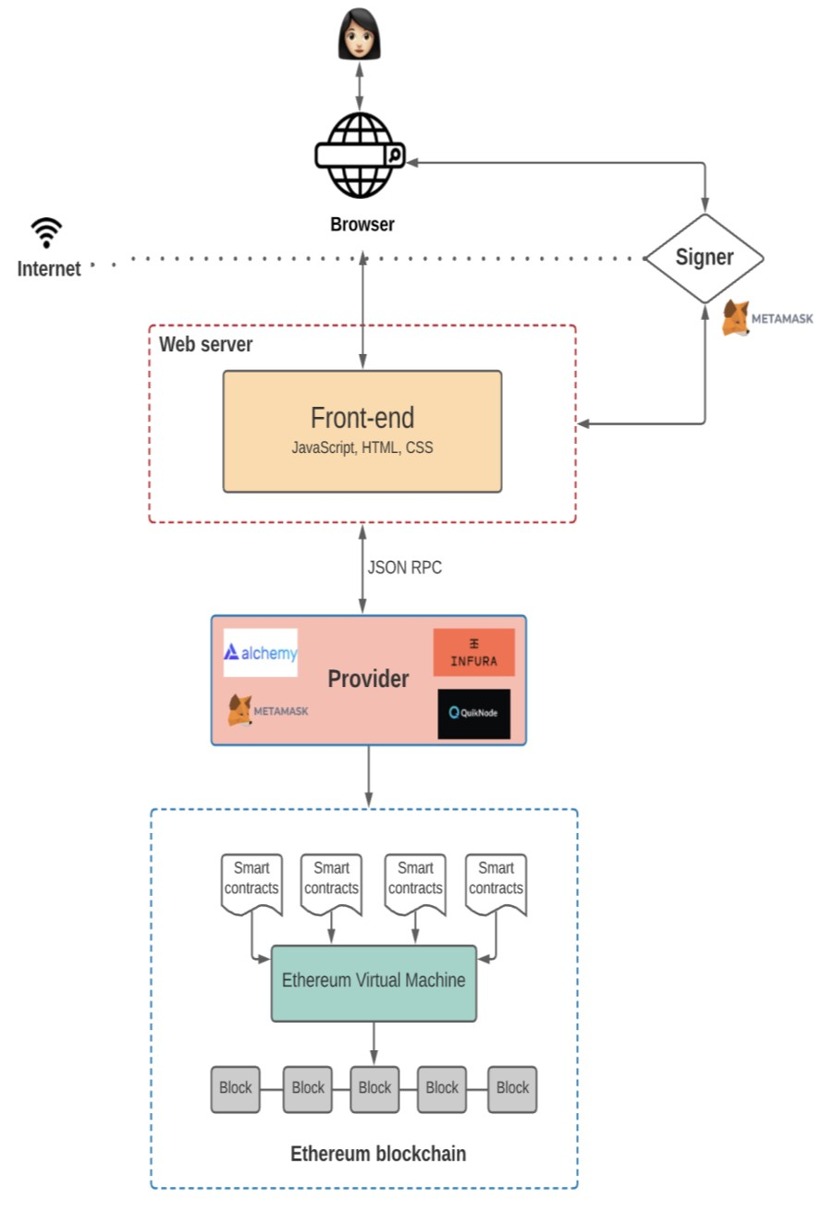

Caption

**Figure 1.1**

### 3.2 Architecture

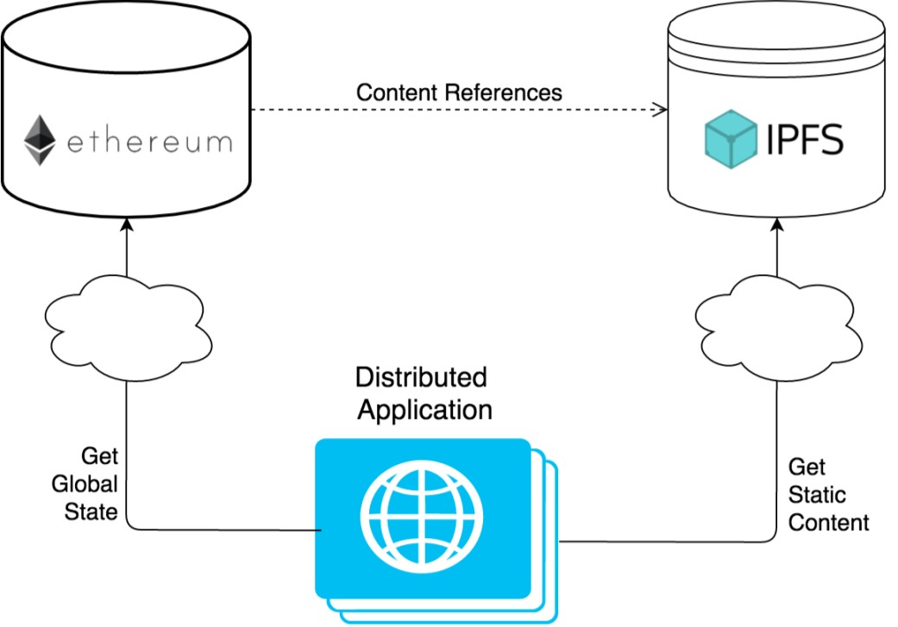

Caption

#### Figure 1.2

**3.3 Details of Hardware & Software**

**Hardware**

* RAM: 4 GB
* Storage: 256 GB
* Architecture: 32-bit or 64-bit
* CPU: 2 GHz or faster
* Internet connection.

### Software

* Swmai hardhat
* Next js, react js
* Package manager npm
* Studio code ide
* Chrome browser
* Metamask wallet.

#### Results

**Code:**

pragma solidity >=0.7.0 <0.9.0;

contract Upload {

struct Access{

address user;

bool access; //true or false

}

mapping(address=>string[]) value;

mapping(address=>mapping(address=>bool)) ownership;

mapping(address=>Access[]) accessList;

mapping(address=>mapping(address=>bool)) previousData;

function add(address _user,string memory url) external {

value[_user].push(url);

}

function allow(address user) external {//def

ownership[msg.sender][user]=true;

if(previousData[msg.sender][user]){

for(uint i=0;i<accessList[msg.sender].length;i++){

if(accessList[msg.sender][i].user==user){

accessList[msg.sender][i].access=true;

}

}

}else{

accessList[msg.sender].push(Access(user,true));

previousData[msg.sender][user]=true;

}

}

function disallow(address user) public{

ownership[msg.sender][user]=false;

for(uint i=0;i<accessList[msg.sender].length;i++){

if(accessList[msg.sender][i].user==user){

accessList[msg.sender][i].access=false;

}

}

}

function display(address _user) external view returns(string[] memory){

require(_user==msg.sender || ownership[_user][msg.sender],"You don't have access");

return value[_user];

}

function shareAccess() public view returns(Access[] memory){

return accessList[msg.sender];

}}

**Output:**

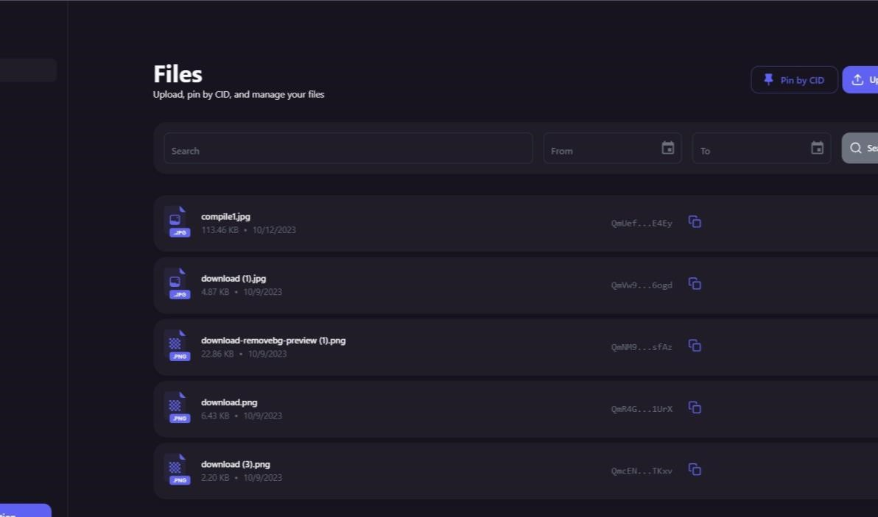

Caption

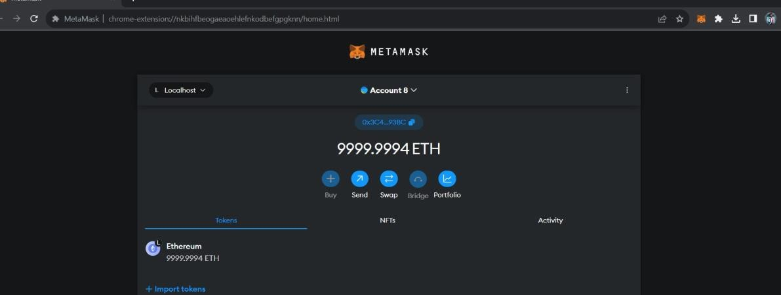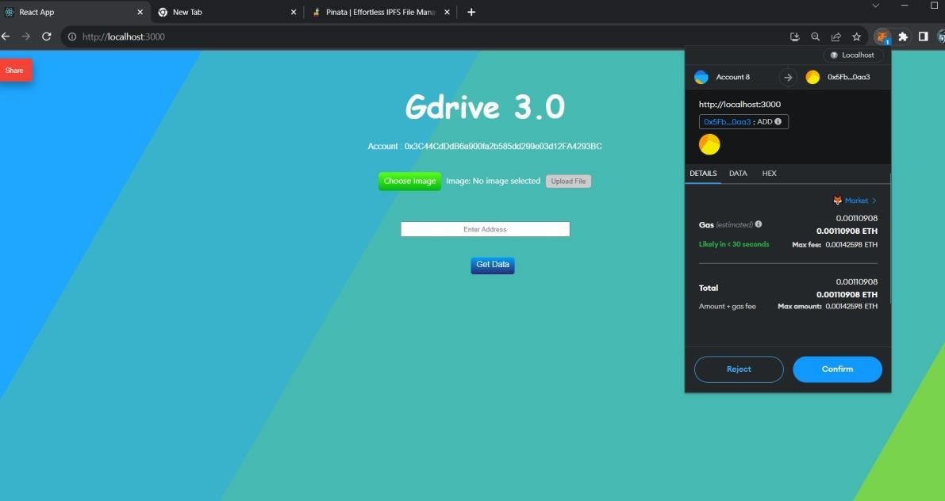

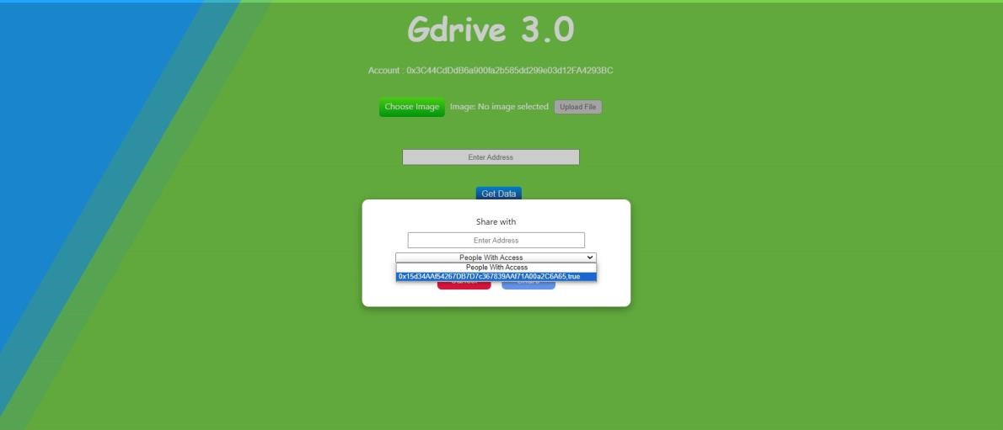

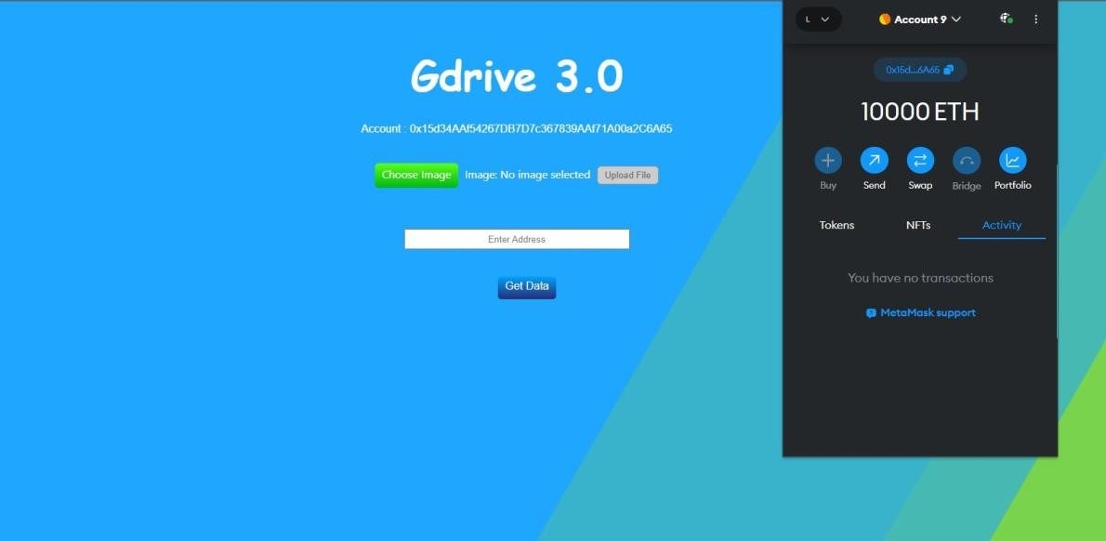

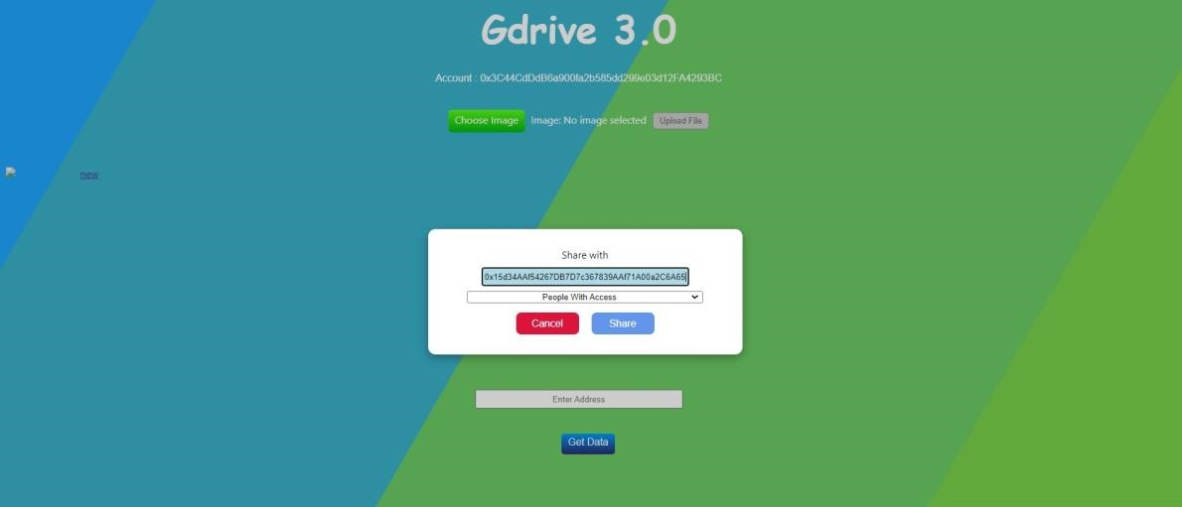

**1. Conclusion and Future work.**

### Conclusion

Rate at which Data is increasing each year is astounding. We need better and efficient Storage Systems. Future of Storage is Decentralization The day is not far when you would be able to rent your storage or computational resource as a part of a DSS and be paid for it.

### Future Work

Future work for a Decentralized Storage System for Documents may involve several areas of development and improvement to ensure the system remains relevant, efficient, and secure. Some potential avenues for future work include:

Enhanced Security Features: Continuous research and development of advanced encryption techniques, access control mechanisms, and threat detection systems to keep pace with evolving cyber threats.

Governance and Consensus Mechanisms: Implement or improve governance and consensus protocols to ensure the decentralized network's integrity and reliability.

Cross-Chain Integration: Explore integration with multiple blockchain networks to provide users with flexibility and cross-chain compatibility.

### Reference

P. Chen et al. "RAID: High-Performance, Reliable Secondary Storage," ACM Computing

Surveys, June 1994, pp. 145-186 Jay J.Wylie, Michael W. Bigrigg, John D.Strunk,

Gregory R. Ganger, Han Kılıççote, Pradeep K. Khosla. "Survivable Information Storage Systems IEEE Computer, August 2000

Jay J. Wylie, Carnegie Mellon University, 2001 "Selecting the right data distribution scheme for a survivable storage system"

Lakshman, A., & Malik, P. (2009). "Cassandra - A Decentralized Structured Storage System". Proceedings of the 28th ACM Symposium on Principles of Distributed Computing - PODC '09. doi:10.1145/1582716.1582722

1. Proskurnia, A. Murdopo, E. Bayarsaikhan, D. Montego "Large-scale Decentralized Storage Systems Used by Volunteer Computing Systems"

R. Hasan, Z. Anwar, W. Yurcik, L. Brumbaugh, and R. Campbell, "A survey of peer-topeer storage techniques for distributed file systems", in International Conference on Information Technology: Coding and Computing, 2005. ITCC 2005, 2005, vol. 2, pp. 205213 Vol. 2

K. Rzadca, A. Datta, G. Kreitz, S. Buchegger, 2015. "Game-Theoretic Mechanisms to Increase Data Availability in Decentralized Storage Systems". ACM Trans. Auton. Adapt. Syst. 10, 3, Article 14 (August 2015), 32 pages.

Large-Scale Decentralized Storage Systems for Volunter Computing Systems - Arinto Murdopol Web: http://www.otnira.com/2012/05/17/dss-for-vc/#more-229